QuickBooks for Windows
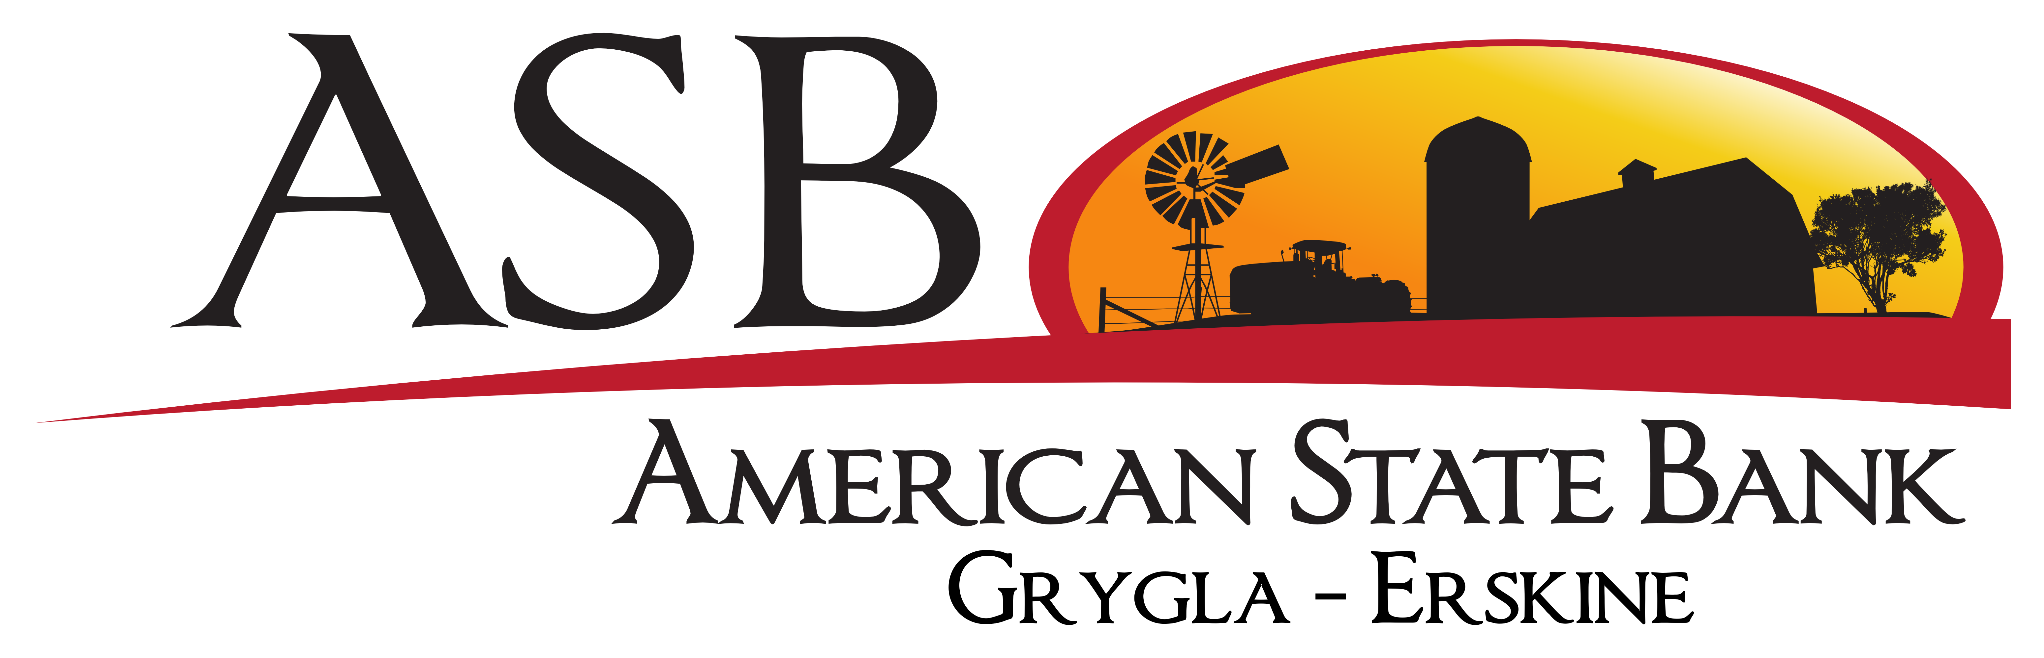

Conversion Instructions
  - Web Connect to Direct Connect

Introduction
As American State Bank of Grygla completes its system conversion, you will need to modify your QuickBooks settings to ensure the smooth transition of your data. Please reference the dates next to each task as this information is time sensitive.
To complete these instructions, you will need your login credentials for online banking and/or Direct Connect.
Direct Connect may require registration. Please contact your financial institution to verify your Direct Connect login information.
You should perform the following instructions exactly as described and in the order presented. If you do not, your online banking connectivity may stop functioning properly. This conversion should take 15–30 minutes.
Thank you for making these important changes!

Documentation and Procedures
- Conversion Preparation
- Backup your data file. Go to File, then select Back Up Company > Create Local Backup and choose a location to save your QuickBooks file.
- Download the latest QuickBooks Update. Go to Help > Update QuickBooks Desktop
If multiple computers do not use the same QuickBooks data file, skip step 3. QuickBooks activities such as Online Banking cannot be performed in multi-user mode because of the way the activities interact with a company data file.
- Switch to Single-user mode if you are currently in Multi-user mode. Go to File> Switch to Single-user mode
If you are not using Classic Mode (Register Mode), enable it for the conversion. You can change it back after the conversion is complete.
- Enable Classic Mode (Register Mode) if you are currently in Express Mode. Go to Edit > Preferences > Checking > Company Preferences > select Classic Mode
- Optional task - Complete a final download before 3:30 Central on 10/4/2019
- Log in to https://www.asbgrygla.com/ and download your QuickBooks Web Connect file.
- Click File > Utilities > Import > Web Connect Files.
- Link your bank account with the existing QuickBooks account and click Continue.
- Repeat steps for each account.
- Match Downloaded Transactions
If new transactions were received from your connection, accept all new transactions into the appropriate registers.
If you need assistance matching transactions, choose Help menu > QuickBooks Help. Search for Matching Transactions and follow the instructions.
All transactions must be matched or added to the register prior to disconnecting your accounts.
- Disconnect Accounts in QuickBooks on or after 10/7/2019
- Choose the Lists menu > Chart of Accounts.
- Select the account you want to deactivate.
- Click Edit menu > Edit Account.
- Click on the Bank Feed Settings tab in the Edit Account window.
- Select Deactivate All Online Services and click Save & Close.
- Click OK for any dialog boxes that may appear.
- Repeat steps for each account to be disconnected.
- Reconnect Accounts to American State Bank of Grygla on or after 10/7/2019
- Choose Banking menu > Bank Feeds > Set Up Bank Feed for an Account.
- Enter, then select American State Bank of Grygla Click Next.
- If prompted for connectivity type, select Direct Connect.
- Link your bank account with the existing QuickBooks account and click Connect.
Verify that all transactions downloaded successfully into your account registers.
- Re-enable Express Mode (if necessary)
If you prefer Classic Mode (Register Mode), you are finished with your conversion. If you use Express Mode for online banking, you may now re-enable the mode.
To re-enable Express Mode register mode (Optional) Go to Edit > Preferences > Checking > Company Preferences > select Express Mode

